Name _________________________________________

**Glencoe Virtual Lab – Electricity**

How are voltage, current, and resistance related?

PRE LAB READING

Electrically charged particles exert forces on each other. There are two types of charges: negative and positive. Atoms are made up of particles that carry these different types of charges. Within an atom, electrons are negatively charged, and protons are positively charged. Other particles called neutrons do not interact electrically with charged particles because they do not carry any charge.

Positively charged particles exert forces that repel each other. Likewise, negatively charged particles exert forces that repel each other. However, particles with opposite charges are attracted to each other. We can harness the energy of this force of attraction to do work for us.

Electricity exists in two forms. As static electricity, electric charges exert forces on each other without moving. As dynamic electricity, electric charges move from one point to another, forming an electric current. Most electric devices such as lightbulbs, televisions, VCRs, computers, radios, and electric motors depend on electricity moving through their circuits.

For electricity to flow in an electric circuit, there must be a conductor, a voltage source, and a source of resistance. The conductor (such as a wire) provides a path through which charged particles (electrons) can move. If the path is broken, electricity cannot flow so there is no electric current.

The voltage source (such as a battery) provides the charges that move through the circuit. Voltage results from an imbalance between positive and negative charges. The voltage source has a positive terminal and a negative terminal. Connecting the two ends of a conductor to the positive and negative terminals completes a pathway through which electricity can flow. The opposite charges attract each other and move through the conductor from one terminal to the other. Electric current will continue to flow until no further imbalance of charges remains. This is why batteries lose their voltage after prolonged use.

The source of electrical resistance, called a resistor, provides a means of controlling the flow of electricity. The amount of resistance depends on the material the resistor is made of. Charged particles actually bump into the atoms of the resistor material, causing a release of energy in the form of heat. A resistor heats up when electric current passes through it.

Ohm´s law states the relationship between voltage, resistance, and current in an electric circuit: Voltage (V) = Current (I) x Resistance (R), or V = IR, where V is measured in volts, I is measured in amperes, and R is measured in ohms.

When there is current in a circuit, work is being done. The amount of work is equivalent to the amount of energy needed to overcome the resistance of the circuit. The rate at which work is done is a measure of the power of the circuit, measured in watts. The electrical power of a circuit can be calculated by multiplying the current by the voltage. That is, P = IV.

Questions

1. How many types of electrically charged particles are there? What do they experience when coming near each other?
2. Name and describe the charges that each particles making up an atom, the fundamental building blocks of any matter.
3. What happens when the same charges come closer? What happens with the opposite charges?
4. Name two types of electricity and describe how they are different from each other?
5. What are the three essential components of an electric circuit?
6. ---- are the particles that flow in a circuit causing in electric current
7. What is voltage? What is the source of voltage in an electric circuit?
8. Why batteries loose the voltage when used continuously?
9. What is a resistor? What role does it have in a circuit?
10. What is one factor that the resistance depends on?
11. Why does a resistor heat up when electric charges pass through it?
12. Name the law that relates the voltage, current and resistance in a circuit?
13. Write and label each variable in the ohm’s law equation with their corresponding units.
14. How is voltage related with a) current b) resistance
15. How are current and resistance related with each other?
16. When can you say that work is being done in an electric circuit?
17. The amount of work in a circuit is equal to -------------------
18. What is electric power?
19. Write the equation for calculating the power and label each variables with their units.
20. How is p related with the V and the I? How are I (current) and V (voltage) related with each other? (analyze the power equation)
21. **Go to the website:** <http://www.glencoe.com/sites/common_assets/science/virtual_labs/E14/E14.html>

Objectives:

* Working with a prewired schematic diagram, design a series circuit using standard components including a resistor, a voltage source, and a switch.
* Use Ohm´s law to describe the relationship between voltage, current, and resistance in an electric circuit.
* Adjust the current in a simple circuit by varying voltage and resistance.
* Calculate the power of an electric circuit.
* Relate the power generated by an electric circuit to the rate at which heat is released by a resistor as electric current passes through it.
* Match the electronic components of a schematic diagram to a physical model.

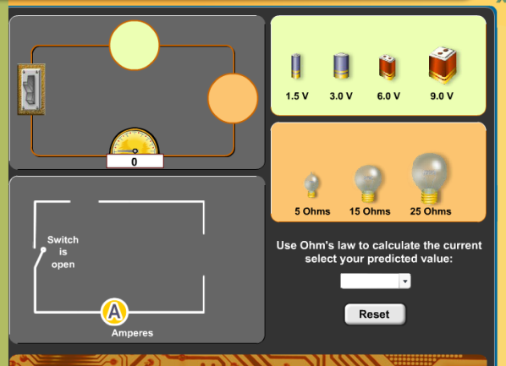**Procedure:**

1. Click and drag a battery and a light bulb to the circuit.
2. Use Ohm’s law to calculate how much current will result from the voltage of the battery and resistance of the light bulb. Select your predicted value from the amperes pull-down menu.
3. Click the switch to close the circuit. Observe the actual current on the ammeter (the device.
4. Record your voltage, resistance and measured current in the table. If the lightbulb burns out, enter 0.0 amperes for the current.
5. Calculate the power generated by the circuit. Record this data in the table.
6. Repeat the steps above using various combinations of batteries and light bulbs.

**Data Table**

|  |  |  |  |  |
| --- | --- | --- | --- | --- |
| **VOLTAGE** (Volts) | **RESISTANCE** (Ohms) | **CURRENT** (Amperes) | **POWER** (Watts) | **OBSERVATION**  (dim, bright, burned out) |
| 1.5 | 5 |  |  |  |
|  | 15 |  |  |  |
|  | 25 |  |  |  |
| 3 | 5 |  |  |  |
|  | 15 |  |  |  |
|  | 25 |  |  |  |
| 6 | 5 |  |  |  |
|  | 15 |  |  |  |
|  | 25 |  |  |  |
| 9 | 5 |  |  |  |
|  | 15 |  |  |  |
|  | 25 |  |  |  |

1. **Conclusion Questions:**
2. What happens to the power of the circuit when the resistance is decreased?
3. Explain how you can determine how much power a circuit will generate if you know the voltage and resistance but not the current.
4. Using Ohm’s law, explain how voltage changes in relation to current, assuming that resistance remains constant.
5. As the electric current in a light bulb is slowly increased, the filament glows more and more brightly. Why does this happen?
6. Why did some of the light bulbs you tried burn out?
7. Why is there zero current when a light bulb burns out?